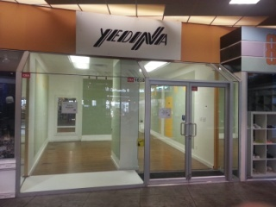
SOLD
#1618 – 4500 Kingsway, Burnaby, B.C. Photos
Metrotown, Burnaby Map
Information Package
Attachments (Log-in Required)
e-mail me about this property
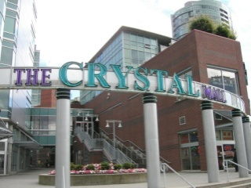
SOLD
#1682 – 4500 Kingsway Photos
Metrotown, Burnaby Map
Information Package
Attachments (Log-in Required)
e-mail me about this property

LEASED
#1618 – 4500 Kingsway Photos
Metrotown, Burnaby Map
Information Package
Attachments (Log-in Required)
e-mail me about this property

